Name: Sapargali Temirlan
Group: SE-2403
Instructor: Aigul Adamova
PART 5
Contract address: 0x25FAAe7bB588c387Ecd614E172c73F2753E6B1DD

Transactions:
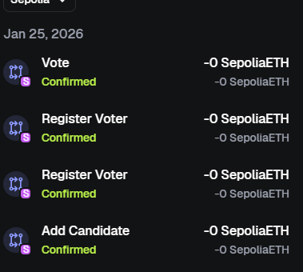
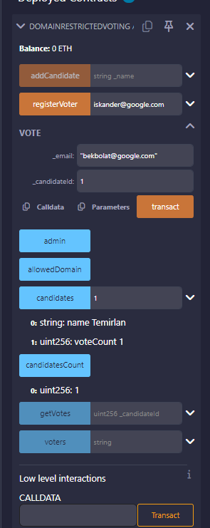

Diagram:
